

**National Park Service**

**U.S. Department of the Interior**

**Assessing the effectiveness and capacity of the**

**VUStats Program**

Final Report



**Prepared by:**

**Gaby Antonova & Will Mulhern**

*National Park Service Business Plan Consultants, 2021*

*Business Management Group*

Contents

I. Executive Summary 2

II. VUStats Background 2

III. Understanding the problem 4

IV. Methods 5

V. Findings 6

VI. Recommendations 15

VII. Implementation 23

Acknowledgements 25

Appendices 25

# I. Executive Summary

The VUStats BPI project assessed the current state of visitor use statistics at the park-level and across NPS regions and programs and provided recommendations to the VUStats team to help more effectively deliver customers service, ensure high quality data, and assist with data utilization and decision-making. The collection and dissemination of visitor use statistics are a legally mandated function of the National Park Service. These data are utilized for a variety of NPS management functions and external research activities. We conducted qualitative interviews with a range of stakeholder across various park units and NPS programs and synthesized our findings into several key focus areas.

We find the primary limitation of the VUStats program is the lack of resource investment in the program on the part of NPS. Additionally, we identify opportunities for improvement in how the VUStats team communicates and disseminates information to users, how count equipment is managed across parks, and how data is presented to end users. Within each of these categories, we provide actionable recommendations aimed at improving the effectiveness of the program and emphasizing the importance of visitor use data management and utilization across NPS.

# II. VUStats Background

The collection of visitor use statistics by the National Park Service has been a key function of the agency since the passage of the Land and Water Conservation Fund Act of 1965 called for funding to the park service to be “the same proportion as the number of visitor days in areas and projects.” This institutionalized a formal need for the collection of visitor use statistics in national park units. The current legal mandate for the collection of visitor use statistics comes from NPS Director’s Order 82, which calls on NPS to “provide a statistically valid, reliable and uniform method of collecting and reporting public use data for each independent unit administered by the NPS.” [1]

Presently, the VUStats program is managed by two staff members within the Social Sciences Program of the Natural Resources Stewardship and Sustainability division (NRSS). Pam Zeisler is the program coordinator, responsible for managing the operations of VUStats and supporting parks in their collection of stats and Claire Spalding is the assistant coordinator working closely with parks to troubleshoot data collection issues and perform data quality assurance. Together, this team is responsible for overseeing the collection and maintenance of 379 parks collecting VUStats.

Aside from the legal mandate to collect information on visitor use, VUStats provide a crucial set of data relied on by NPS for decision-making, including:

* Park planning and management decisions
* Regional planning and management decisions
* Allocation of GAOA funds
* Economic impact estimates for local communities
* Damage assessments
* Asset management and valuation

In the last decade, both park visitation and the number of reporting park units have grown, while the size of the VUStats team has remained constant with only two positions – one of which was unfilled for several years.

**Figure 1.** Park visitation and number of parks by year, IRMA Annual Summary Report for all parks, 2009-2019

# III. Understanding the problem

The growth in both visitation and number of parks under NPS management has increased the burden on the VUStats team to adequately support parks in the collection of accurate and timely visitor use data. Our consulting team aimed to better understand the current state of the VUStats program from the perspectives of the parks that collect visitor use data and use it to inform decision making, and the end users that rely on VUStats data to make crucial decisions within NPS. We assessed how the VUStats team can best support parks and provide more effective customer service to data collectors and data users to promote more accurate and actionable visitor use data.

**Project Statement of Work**

How might the NPS Social Science Program better deliver critical information to its customers about NPS Visitor Use Statistics to enhance customer experience and improve data quality and usability?

One of our goals was to provide an analysis of the importance of a strong visitor use statistics program and the risks of an under-resourced program. We present these results in the Findings section of this report and have prepared an additional memo*, The Benefits of Additional Resource Investment in the VUStats Program,* that expounds on this analysis.

*Problem Framework*

The work of the VUStats team can be categorized into three key areas: supporting data collection and operations at the park-level, ensuring accurate and high-quality data, and supporting the utilization of data in decision-making. We identified areas where improvements could be made to provide more effective service to parks and end users. Figure 2 shows this framework and a brief description of each area.

**Figure 2.** Problem framework

# IV. Methods

To better understand the challenges faced by data collectors, data users, and superintendents in collecting and using VUStats data, our team conducted semi-structures interviews with stakeholders, evaluated online resources, and performed a thematic analysis using human centered design principles. The team conducted 42 interviews with 52 data collectors, data users, and superintendents, with a 78% overall response rate.

Participant Selection

Data collectors

The data collector participant group consisted of park field staff responsible for collecting and entering visitor use statistics at their respective park. These individuals have data collector permissions in IRMA enabling them to input data. The roles of individuals responsible for data collection vary from park to park.

We selected a stratified random sample of three parks from each of the eight park strata from the pool of 379 reporting park units. This sample procedure is the same as the procedure developed for the first year of the Socioeconomic Monitoring Program (SEM). The eight park strata are based on level of visitation and park type:

1. Historic-Urban Low Visitation (HUL),
2. Historic-Urban High Visitation (HUH),
3. Historic Non-Urban Low Visitation (HNUL),
4. Historic Non-Urban High Visitation (HNUH),
5. Natural Low Visitation (NL),
6. Natural High Visitation (NH),
7. Rural Low Visitation (RL)
8. Rural High Visitation (RH).

The objective was to interview at least two parks per strata. If we were not able to meet this goal with the original list, we selected parks from a reserve list drawn using the same sampling technique. We were able to interview two or more data collectors for all strata except for HNUH, due to scheduling conflicts.

Data users and superintendents

We selected data users and superintendents based on their engagement with the VUStats team rather than through random sampling. The VUStats team is only aware of data users who reach out to the team for help since the visitor use statistics data set is publicly available. It was not possible to supplement the data user participant pool with randomly selected individuals.

To minimize bias in the superintendent pool, we utilized a snowball sampling technique in which supplemental superintendents were interviewed based on referrals from the original list of participants and additional superintendents were added from sites hosting 2021 Business Plan Interns. This resulted in a participant pool of superintendents with varying levels of engagement with the VUStats program. Appendix A contains the full list of interview participants.

Interviews

We drafted, reviewed, and piloted a custom interview guide based on relevant topics for each participant group. Appendix B contains the complete interview guides. We conducted interviews primarily over Microsoft Teams video calls, with two interviews conducted by phone and two in-person. Interviews took 30-60 minutes, on average, and all but one was recorded with the consent of the participants.

To ensure transparency, we told participants their responses would not be shared with parties external to NPS and gave the option to anonymize responses to specific questions. No respondents requested anonymity.

Analysis

Interview Data Analysis

We manually coded interviews at a high-level. For each question, we identified general categories of responses to develop an interview code book. We coded each interview based on the code book and developed summary statistics from the coded data.

Evaluation of online resources

Our team reviewed online resources including IRMA, the VUStats SharePoint, and the Common Learning Portal (CLP) and evaluated the usefulness of these resources as inexperienced users.

# V. Findings

Our qualitative analysis revealed high-level findings regarding the importance of a well-resourced VUStats program as well as specific findings within the three areas of the problem framework: data collection, data quality, and data utilization in decision-making.

Reliable visitor use statistics are crucial to NPS operations and decision-making

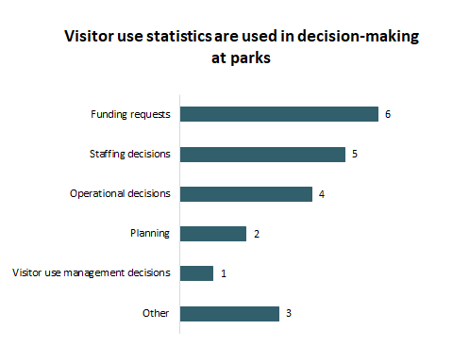Nine out of ten superintendents who participated in interviews stated they use visitor use statistics in decision-making at their park, most frequently for funding requests, staffing decisions, operational requests, planning, and visitor use management decisions. The superintendent from Saratoga National Historic Park shared, “(Visitor use statistics) are so helpful in management decisions and looking at benefits to the park and how we understand what is happening to the park if you are not out there.”

**Figure 1.** Reported uses of VUStats

More than two thirds of park data collectors and superintendents reported sharing their visitor use statistics with community members and external partners, including Congressmembers, local governments, state tourism departments, local economic development groups, chambers of commerce, media outlets, cooperating organizations, and park donors. The superintendent at Little River National Preserve and Russel Cave National Monument shared, “I’m using (VUStats) now trying to get a budget increase for the park. Showing that we do not have enough staff. Our Friends Group is using this data to lobby Congress. We’re using this data a lot.”

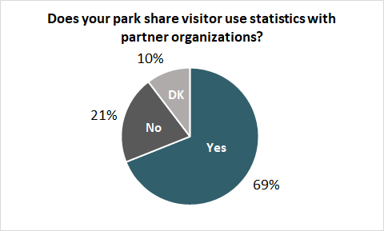

**Figure 2.** External sharing of visitor use statistics.

Despite the widespread use of visitor use statistics in park, regional, and national level decision-making, most interviewees do not feel their park’s count procedures is sufficient to capture visitation (Figure 5).

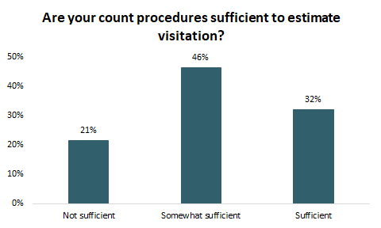

**Figure 3.** Accuracy of count procedures

These findings illustrate a key disparity: while most parks report relying heavily on VUStats for decision-making and park-planning, many are not confident in the numbers they are using. This finding emphasizes the need for improvements to the VUStats program. The rest of our analysis provides insights regarding possible areas of opportunity for strengthening the VUStats program.

The VUStats team is at capacity

Based on our analysis, the major limiting factor to improving the VUStats program is the time available for the VUStats team to work on improvements. The VUStats team currently consists of only two full-time staff members. While the team possesses an expertise in visitor use data collection, data management, and social science research, they are constrained by their available time, a backlog of requests from the 379 parks for which they manage data, the flow of requests, and new projects requiring their attention.

The team does an excellent job of managing day-to-day operations of the program, as evidenced by the overwhelmingly positive feedback from interviewees. The superintendent from Guadalupe Mountains National Park shared, “I find that (the VUStats team) is very responsive in getting back to us, setting expectations around ‘we can help you, but we need XYZ’. I’m a superuser, I am coming at this with over a decade of engaging that office.” However, the number of requests limits the VUStats team’s capacity to implement higher level programmatic improvements.

According to interviews with the VUStats team, an estimated 50% of the team’s time goes to addressing customer service requests from parks. The flow of customer service requests goes directly into the inboxes of the VUStats team. This includes the most basic questions about online resources and using IRMA. According to Pam Ziesler, an estimated 15% of the team’s time goes to addressing these frequently asked questions. A portion of the remaining time goes to checking data quality and data cleaning, leaving a limited amount of time for assisting parks with making improvements to their data collection processes or supporting analysis of VUStats in decision-making.

The VUStats program currently has a backlog of over 200 projects, including updating count procedures and performing park audits. The new Socioeconomic Monitoring project requires the support of the VUStats team which will require additional time and effort. Rising park visitation and the protection of additional lands under NPS management will continue to constrain the availability of the VUStats team and pose a significant risk to the accuracy and quality of VUStats within NPS.

Areas of focus

Utilizing the previously outlined framework, we organized our findings into three specific categories based on the primary research question presented in the SOW and the goals of the VUStats team:

1. Data collection and operations
2. Data quality
3. Data utilization in decision-making

Analysis of our qualitative interview data indicated that most data collection challenges faced by parks fell into these areas of focus. Common challenges included equipment issues, inadequate count procedures, park geography, and a general lack of resources (Figure 6).

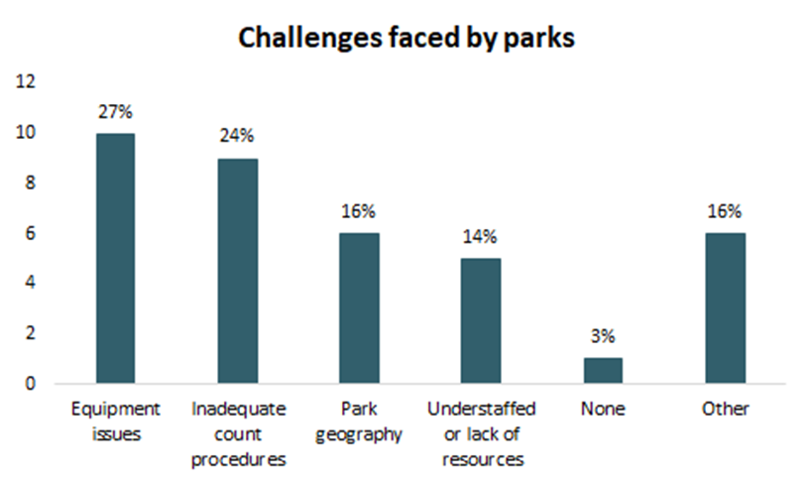

**Figure 4**. Common challenges to collecting VUStats

Data Collection and Operations

Park staff are spending a significant amount of time on visitor use data collection

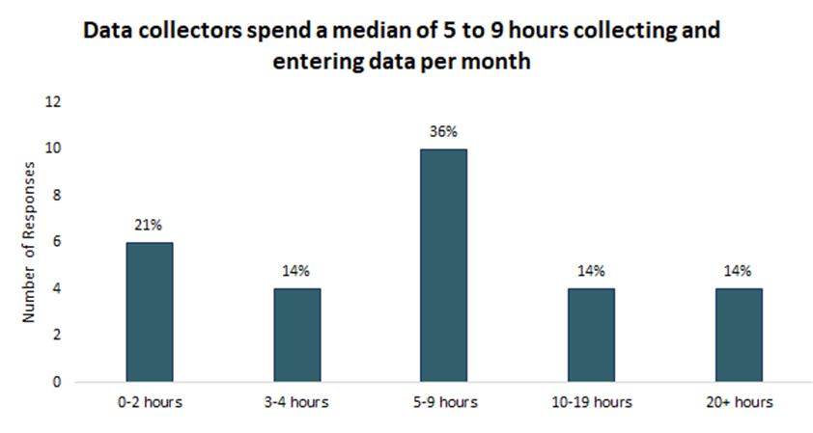Data collectors spend a median of five to nine hours collecting and entering data per month, a significant burden given other responsibilities. Parks are spending different amounts of time collecting and entering data primarily based on differences in park type, park size, and complexity of count procedures.

**Figure 5.** Average time spent on data collection by parks

A lack of formalized training

Most data collectors do not receive significant formal training regarding the VUStats program and data collection methodology. Half of data collectors interviewed stated they received no training collecting and entering VUStats. Eight out of eighteen data collectors interviewed stated they received some training collecting and entering VUStats, while only one stated they received significant training.

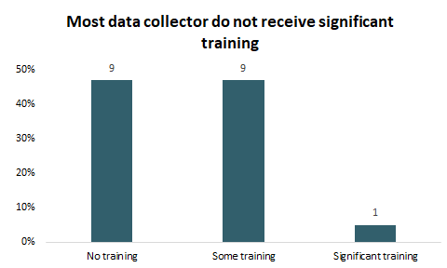Data collectors receive an introductory email from the VUStats team with links to relevant online resources and a brief guide to getting started in IRMA. After that, the burden of training falls on parks and is largely informal. If there are previous data collectors at the park, they may briefly train the new data collector. A data collector at Gateway Arch National Park shared, “I just inherited the data input. The person who had done it before me took five minutes to go over what he had been doing.”

**Figure 8.** Training received by data collectors

If there is no previous data collector at the park, the new data collector can informally reach out to the VUStats team. An estimated 50% reach out to the VUStats team, according to Pam Ziesler. The remaining new data collectors receive no training and piece together data collection duties on their own.

Most data collectors have expressed that more training, especially training helping them understand the importance of visitor use statistics, would be beneficial to their park and would motivate them to prioritize their duties as data collector.

Standard Operating Procedures (SOPs) have not been developed for many parks

Most parks do not have formalized visitor use data collection SOPs. Sixty-three percent of parks do not have formal SOPs and half of those that report having some form of SOP have only informal documents. A data collector at Fort Laramie who has been responsible for visitor use statistics for over four decades shared:

*It pretty much just lives in my head, at one point we did have (an SOP), but it has not been updated for some time … People move in and out of the parks too fast to pass that information on orally. So, I think (we need) a hard copy document.*

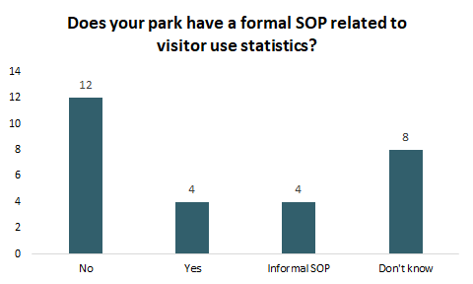

**Figure 6** - Data collection SOPs

Online resources are available but remain underutilized

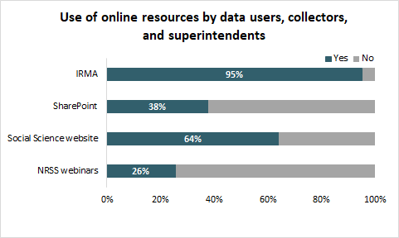Most data collectors, superintendents, and data users exclusively use IRMA and are unaware of other online VUStats resources. Superintendents and data users visit the Social Sciences page to look at Visitor Spending Effects, but not as a resource for visitor use statistics.

The Common Learning Portal (CLP) is particularly underutilized. There are only 140 members of the CLP, while there are over 600 data collectors. Data collectors are largely unaware of available training resources, emphasizing the need for greater utilization of the VUStats SharePoint. A data collector at Mount Rainier National Park shared, “Didn’t even know there was (a SharePoint site). That is really good information.”

**Figure 7.** Use of online resources

Quality of data

Count procedures are updated irregularly

Although park procedures should be updated regularly to represent changes to visitation trends and park facilities, some parks lack the resources and knowledge to manage regular updates. Only 12 out of 29 interviewees stated their park had updated count procedures recently, to their knowledge. Many parks have not updated count procedures for over ten years, with some not making updates since the early 90s.[2] A data collector at Fort Laramie expressed, “the park service needs to figure out some kind of schedule so that the stats are actually valid.”

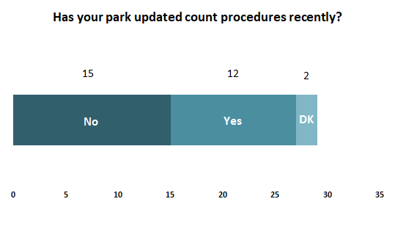The key barriers to updating park count procedures are: 1) parks are unaware of the process for updating count procedures, and 2) the VUStats team does not have the capacity to update all count procedures at a regular interval. Many parks expressed a desire to update count procedures but were unsure of how to start the process or secure funding. Pam Ziesler shared, “Ideally, (count procedures) would be updated every five to ten years, I’d say about every seven. This would be sensible based on my experience. At one time, I figured we’d need about six people to do this. This may grow as we add parks.”

**Figure 8.** Have parks recently updated count procedures?

Parks often experience issues with equipment and technology

Seventy-six percent of parks had issues with equipment, primarily related to vandalism and theft, purchasing, tracking, and weather damage. Many urban parks reported stolen equipment or vandalism of equipment, and stated visitors often think counting equipment might be surveillance equipment. A data collector from Golden Gate National Recreational Area shared:

*We have lots of issues with vandalism of counters. The automated counters have electronics, and we need to take extra precautions in housing or hiding counters to prevent vandalism. Or we just end up repairing and replacing them more often. We’re an urban park and deal with urban problems.*

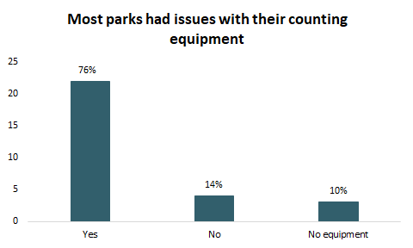

**Figure 9**. Most parks had issues with their counting equipment

Parks face a significant burden related to researching and purchasing their own counting equipment. Most parks purchase similar equipment but select brands based on park staff’s research. Some parks purchase inadequate equipment and find better brands through a trial-and-error approach, placing a burden on park budgets and staff time. The superintendent at Saugus Ironworks National Historic Site shared, “we need to have someone in place who can say ‘here are the 45 pieces of equipment that are most needed at parks’ and have them available.”

Other equipment issues include tracking, maintenance, and weather-related issues. Remote parks face challenges with accessing equipment, making maintenance difficult. Marine parks and parks that experience difficult weather conditions, such as seasonal fires, require durable and weather-proof equipment not always readily available to them. A data collector at Golden Gate National Recreational Area shared “in a marine environment, our counters oxidize really easily. We have to resort to 3- or 5-year averages when that happens.”

Data utilization in decision-making

IRMA is unintuitive and only easy to navigate for experienced users

Data in IRMA is relatively easy to access for users who are familiar with the platform but is unintuitive for less experienced users. One regional interpretation planner stated:

*I (find it easy to navigate) because I know what I’m looking for. But I don’t think other people do. The menu page is inconsistent. I don’t think it’s intuitive for a lot of people unless they use it a lot.*

Another data user shared they often click into multiple reports before finding the one they need. This poses a challenge when connectivity is limited as it takes time and bandwidth to open multiple links. Data users also shared that they often require raw data from IRMA and are unable access it.

To provide specific feedback on the usability of IRMA, we conducted our own analysis of the site and share detailed feedback on potential changes in Appendix E. In general, we find the inconsistency of reports across parks, difficulty of finding specific reports, and lack of customizability of what data is accessible to be the main barriers to utilizing the stats platform on IRMA.

There is insufficient transparency regarding data quality

Multiple users reported issues with understanding the underlying quality of VUStats data. Users reported trouble understanding to what extent a park relies on estimates rather than hard counts. There is no information about the accuracy of a particular park’s count procedure to allow data users to adjust for potential issues in analyses. Users also reported difficulty understanding when changes in count procedures occurred within parks and noted it was difficult to compare across years given the lack of information around these changes. One data user summarized these issues:

*I’d like to see variability built in. Being an end user, I don’t know anything that’s going on in any of the parks. I don’t know if the variability has anything to do with how they are collecting data or changes in the process.*

Superintendent data utilization

While our group of superintendents was biased toward those with more exposure to VUStats, multiple superintendents indicated they do not think most of their peers are utilizing VUStats data to the same extent they are. One superintendent stated they were not confident enough in the numbers to use them for these types of decisions, despite a desire for more data-driven decision-making:

*Because I think we’re getting such limited numbers as to what’s actually happening, sadly we are making more decisions based upon inference … (planning decisions) are not really based on numbers, it’s based on (what we’re seeing in) our field. We’d sure love to base it on numbers.*

Superintendent, LEWI

Our interviews also identified a lack of formal training as a significant barrier to implementing a more data-driven approach to park decision-making. Two different superintendents, both regular users of VUStats, pointed to the lack of formalized training around VUStats for superintendents as a main driver of this inconsistency:

*As a superintendent, getting trained up on what visitor use stats you have and how it can help you manage the resources of the park. It’s not something, as a new superintendent, you really get trained on. There needs to be a lot more training at that superintendent level.*

Superintendent, LACL

*The opportunity here is that VUStats is not being represented at the (superintendent) level. There is an opportunity to somehow change that. There is a critical need to put (VUStats) in front of superintendents.*

Superintendent, GUMO

Without a basic introduction to VUStats, superintendents are less likely to prioritize visitor use statistics and effectively utilize stats in decision-making.

# VI. Recommendations

Based on the results of our qualitative analysis and the needs expressed by data collectors, data users, and superintendents, we propose a series of recommendations that are grouped into four categories. The first three categories are tied to the specific key areas identified in our framework, while the fourth supports all three key areas:

1. Improve communication
2. Address equipment challenges in parks
3. Improve data usability for end users
4. Expand the capacity of the VUStats team

Figure 13 lists the four recommendation categories and the key areas of focus they are intended to improve. Within each of these categories, we provide specific recommendations for meeting these broader goals. Each of the recommendations has an associated timeframe to assist with prioritization: short-term actions can be done relatively easily by the existing VUStats team, medium-term actions will take more effort but could be feasible with the existing staff or a small increase in team capacity, and long-term actions will require additional resources and engagement beyond the scope of the VUStats team (i.e., Directorate-level support).

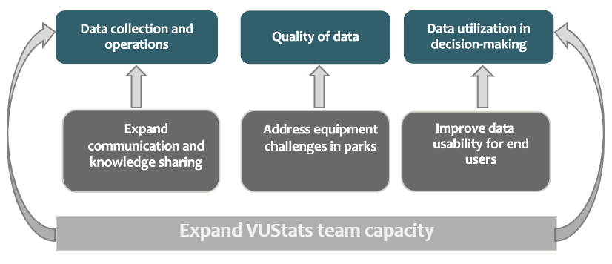

**Figure 10**. Categories of recommendations and related components of the problem framework.

Improve Communication

Improving communication between the VUStats team and parks and across park units would improve the efficiency and accuracy of data collection and reduce the time the VUStats team spends responding to basic customer service questions. The following recommendations are aimed at addressing the existing communication challenges.

Centralize online resources. (short-term)

Centralizing all online resources in IRMA would increase the utilization and accessibility of available tools. Most park staff have trouble tracking multiple VUStats webpages. Ninety-five percent of interview participants reported using IRMA, making it a logical location for sharing VUStats resources. The VUStats SharePoint, CLP, and any other useful resources should be linked under the “Home” or “Useful Links” sections in IRMA so users can intuitively navigate to these resources.

Create a ticketing system or contact form for contacting the VUStats team. (medium-term)

Creating a ticketing system would allow park staff to make specific requests accessible to multiple members of the VUStats team.The landing page for the ticketing system should have a list of frequently asked questions which would reduce the number of emails the VUStats team receives. The list of FAQs would include links to trainings in SharePoint, IRMA, and equipment recommendation documents. This system would also encourage data collectors, users, and superintendents to troubleshoot basic problems before contacting the VUStats team. It would create a central place for storing park staff requests for support that is accessible to multiple VUStats team members. The ticketing system should have a drop-down menu where the customer can indicate the type of issue they are experiencing. One of the drop-down menu options could allow the customer to select “request for equipment.” This would allow the VUStats team to keep a record of parks that need count equipment as funding becomes available to fulfill equipment requests.

A form on SharePoint allowing users to submit requests directly to an email shared by the VUStats team would be the most straightforward and efficient method for implementing this system. The existing Solution for Technical Assistance Request (STAR) Database, which currently exists on IRMA, could be used for longer-term requests, but would not provide the opportunity for immediate assistance often needed by data collectors. A continuously monitored SharePoint form would centralize requests without slowing response times.

Streamline the VUStats SharePoint and the Common Learning Portal. (short-term)

Streamlining the VUStats SharePoint and Common Learning Portal and improving the awareness of online resources through standardized trainings will improve data collector and superintendent understanding of visitor use statistics. Appendix C includes specific recommendations for redesigning the VUStats SharePoint and the CLP.

Improving awareness of the CLP by actively inviting new data collectors to the platform would also enable more collaboration across parks, something multiple data collectors noted would be helpful. Different threads could be opened in the CLP based on park type which would enable collaboration across similar parks.

Establish consistent email communication with park staff. (short-term)

Consistent quarterly communication, with updates relating to VUStats, would increase the visibility of the VUStats program. Partnering with an NPS group that already distributes a regular newsletter and requesting the addition of a small VUStats section would be an effective way to achieve this without creating a VUStats newsletter. It would also capture the attention of NPS staff that may not have enough awareness of the VUStats program to subscribe to a separate newsletter. Possible existing newsletters that could host a VUStats section include “News from NROC” and the “PPFL Newsflash.”

Create standardized data collector and superintendent training materials. (medium-term and long-term)

*User Guides (medium-term)*

Providing standardized training materials for data collectors and superintendents would improve the consistency of data collection and park-level understanding of the uses and importance of visitor use statistics. There are several reference documents on the SharePoint, most serve as training documents for data collectors. Data collectors are largely unaware of these resources. Converting these reference documents into a searchable Data Collector User Guide and linking it in IRMA would increase the accessibility of this resource.

There is currently no procedure for introducing new superintendents to the VUStats program. Several superintendents have asked for more resources and trainings related to VUStats. Creating a Superintendent User Guide and including it as part of the resources developed for the new Superintendent Academy, would provide superintendents a resource for familiarizing themselves with visitor statistics. Pam Ziesler is currently working on creating user guides, however the VUStats team has had difficulty finding time to finalize these given the need to provide direct customer support to parks. Expanded capacity for the VUStats team, as outlined in a later recommendation, would allow the team to focus on developing these guides and similar training materials.

*Annual Trainings and Webinars (long-term)*

In the long-term, annual trainings for data collectors and superintendents would help improve the consistency of data collection and help parks learn to better leverage their visitor use statistics for managing park planning and priorities. This would take additional staff and resources than the VUStats team currently has available.

Develop case studies highlighting the importance of accurate visitor use statistics.

Developing case studies demonstrating the importance of VUStats would encourage park staff to collect high quality data and improve NPS-wide understanding of the value of accurate visitor use statistics. We recommend the VUStats team work with unique users of VUStats to develop case studies. An example of this could be the Resource Protection Branch, who rely on visitor use statistics to conduct damage assessments that in turn provide reimbursements to parks when damage occurs.

Address equipment challenges

Nearly every park reported challenges with purchasing, installation, or maintenance of count equipment. Equipment challenges pose a significant risk to the quality of VUStats data and create unnecessary burden on park staff who troubleshoot these challenges.

Further develop and distribute documentation for best equipment brands and models for different park geographies and needs. (Short-term)

Though the VUStats team has developed several documents with equipment recommendations, many park staff are doing their own research when purchasing new counting equipment. Often, this results in trial-and-error assessment of equipment resulting in lost staff time and financial resources. Standardization of equipment would reduce staff training time, especially since NPS staff frequently go on detail. Including clear and succinct documentation outlining the most effective count equipment for specific park types in a comprehensive equipment guide saved on SharePoint would make the information more accessible to park staff.

The following criteria should be used in creating the equipment recommendations to be included in the guide:

|  |  |  |
| --- | --- | --- |
| Criteria | Description | Park Type |
| Cost | Affordability of the equipment compared to its longevity. | All |
| Usability | Ease of use, maintenance, and installation. Counters should only include features necessary for capturing visitation and should not have any features that make the device more difficult to use. | All |
| Durability | Longevity, including weather proofing against rain, snow, and ocean spray. | All |
| Discreetness | Discreet appearance to the public or ability to be hidden while still performing key functions. | Emphasized by urban parks |

**Table 1.** Criteria for recommending count equipment

Provide recommendations to parks for avoiding vandalism of equipment. (Short-term)

Parks with varying geographies, particularly urban parks, reported vandalism and theft of equipment. Some parks have built custom lock boxes which have generally helped resolve the issue. Providing parks with a way to share their strategies for protecting equipment could help improve standardization. This information could be shared through the CLP.

There is evidence that labeling scientific equipment with an empathetic message explaining what the equipment is used for and asking the public to not tamper with equipment can reduce negative interactions by 39% (Clarin et al., 2014).[3] Several park staff members have shared that the public often vandalizes or steal equipment because they mistake counter for surveillance equipment. Labeling counters would prevent the public from damaging equipment to protect their privacy. Other possible labels can indicate counters are property of the federal government or labels indicating the equipment is under surveillance for security, to discourage vandalism. Options for signs include:

* 1. “Property of Federal Government”
  2. “Equipment under surveillance - GPS monitored”
  3. “Property of the National Park Service – Used for park management - Please do not touch – if you would like to know more please visit [Visitor Use - Social Science (U.S. National Park Service) (nps.gov)](https://www.nps.gov/subjects/socialscience/visitor-use.htm)”

Provide standard recommendations for securing funding for count equipment. (Short-term)

Creating a document outlining how to secure funding for equipment would help parks maintain working count equipment and allow the VUStats team to use year end funds on parks with outstanding equipment requests.The document should be included in the equipment guide and should explain how to enter count equipment needs into PMIS.

Another option for securing equipment funding could be submitting a request to the VUStats team. Including requests for equipment funding in the proposed VUStats ticketing system would allow the VUStats team visibility into park equipment needs when determining how to spend down any remaining year end budget.

Create an organization-wide method for tracking count equipment. (Long-term)

Implementing a system for tracking counting equipment would help NPS understand how much the organization is investing in this equipment. Unlike other NPS assets, counting equipment is not tracked in an NPS database, although a single traffic counter can cost upwards of $500. We have identified two options for implementing this tracking:

*Tracking equipment in FMSS would allow parks to track their count equipment in a centralized database.*

Parks already have access to FMSS and there is an existing asset category for traffic counters. This indicates that transitioning to tracking counting equipment in FMSS would not pose significant challenges.

*Creating new fields in VUStats to track counting equipment, like traffic and trail counters.*

Creating a field with a drop-down menu with common counter types, as well as a field to indicate the number of each counter would help parks track equipment. This new field would also provide VUStats with insight into which count equipment most parks use. Creating an additional field to indicate which equipment is “functioning” and “non-functioning” would create transparency regarding which parks need new equipment. The additional field could be added so parks can confirm the date of the most recent inspection.

**Establish a relationship with counting equipment providers (i.e. TRAFx or Diamond Traffic counters). (Long-term)**

NPS should consider options for engaging with traffic counter companies through bulk ordering or a potential contract. Parks are buying equipment on an individual basis, which places a burden on staff time and costs more than purchasing equipment in bulk or through a contract. Establishing a relationship with counting equipment providers could provide reduced prices for equipment and would allow for better technical support from the manufacturers. TRAFx also has a data platform, DataNet, which allows for storing more geographically and temporally granular data. Most data users have requested more granular data in to better perform their jobs, and several data users have cited doing their own visitation studies for specific park planning projects.

Improve Data Usability

Indicate data quality to internal users. (Short-term)

Given our findings about data users’ uncertainty around data quality, we propose an internal data quality rating system that provides users with more insights regarding data confidence. This system will help users better understand the accuracy of VUStats data and the challenges faced by specific parks in collecting and reporting these data. The system consists of the following four criteria which are then aggregated to provide a total score for every reporting park unit:

1. Time since last count procedure update
2. Reliance on estimates vs hard counts
3. Difficulty of data collection based on park geography
4. VUStats team confidence in the data

Appendix D contains a proposed methodology for this rating system. The methodology is designed so three of the four domains can be assessed by reading a park’s count procedure. This will minimize the time required for the VUStats team to calculate these ratings. Scores for individual criteria should also be listed to provide insight into the specific issues parks face and to help prioritize troubleshooting by the VUStats team.

In the short-term, the VUStats team can finalize the rating system and begin to score parks that they consult with on a weekly basis. Complete implementation of the data quality rating system will take time and may require significant help from interns.

Flag changes in count procedures. (Short-term)

Flagging the years in which changes to count procedures are implemented at parks would allow data users to understand the context behind fluctuations in visitation. Changes to park count procedures can make comparisons of VUStats across time periods difficult and unreliable. Several data users noted this challenge and said it would be helpful if the VUStats site provided indications of when changes in count procedures occurred in IRMA. This could be done with an asterisk in the report next to the year where a count procedure change occurred.

Improving Navigability of IRMA. (Short/medium-term)

We reviewed IRMA, documented feedback, and suggested changes to improve the navigability of IRMA. Appendix E contains specific suggestions for making IRMA reports easier to customize and navigate.

Expand VUStats staff capacity

While the VUStats program is well-managed given existing resources, there is opportunity for expanding the program to provide more accurate data to the park service. Expanding the capacity of the VUStats team is a necessary step for strengthening the program and improving data-driven decision making throughout NPS.

With additional support, the VUStats team could allocate more time to growing the program’s capabilities. We propose three options for expanding the capacity of the VUStats team. These options vary in investment required on the part of NPS and are not mutually exclusive. At minimum, we see the creation of a regional task force as a necessary step in improving the reach and capabilities of the VUStats program. This would significantly expand the reach of the VUStats team and would also contribute to the need for improved communication regarding VUStats across NPS.

|  |  |  |  |
| --- | --- | --- | --- |
| Option | VUStats team capacity | Accountability and engagement | Cost |
| Create a VUStats task force with a representative from every region. | Slight increase | Moderate | Low |
| Hire a new administrative staff member on the SSP. | Increase | Low | Moderate |
| A new staff member in each regional office focused on supporting VUStats and the SPP. | Significant increase | High | High |

**Table 2:** Comparative assessment of options for increasing the capacity of the VUStats team

VUStats “task force” with a representative from each region. (Short-term)

The capacity of the VUStats team could be expanded without hiring additional staff through the appointment of specific regional team members to a “VUStats task force.” This task force would be composed of staff with a vested interest in VUStats or working in roles where VUStats are heavily used. This may include regional planning staff or regional interpretive planners. Members of the task force would serve as a first point of contact for parks with questions or challenges regarding VUStats. They would also help raise awareness of the VUStats program by periodically sharing information with parks and disseminating information and data to the entire region.

Additional staff member on the Social Sciences Program to fill a customer service and administrative role. (Medium to long-term)

Hiring a new staff member to support the entire Social Sciences Program, with at least 50% of their time dedicated to customer service for the VUStats team, would help free up the time of existing VUStats team members to focus on more program-level initiatives. The main function of this individual would be to field customer service requests from parks and data users, helping parks to navigate common challenges and troubleshoot basic issues. This role would act as the “first line of defense” and would attempt to troubleshoot issues and escalate to the appropriate staff when necessary. This would allow the VUStats team to spend more time focusing on things like updating count procedures, helping coordinate visitor use studies, the Socioeconomic Monitoring initiative, external research partnerships, as well as other high-level initiatives requiring more social science expertise.

A new staff member in each regional office focused on supporting VUStats and the Social Sciences Program. (Long-term)

Hiring a staff member in each regional office to serve as a regional representative for the Social Sciences Program, with a heavy emphasis on VUStats, would greatly increase the capacity of the VUStats team. This individual would work directly with parks in their assigned region to troubleshoot VUStats data collection issues, updated count procedures on a regular basis, support visitor use studies, and broadly ensure the quality of VUStats data at each park in the region. The existing VUStats staff would oversee the work of these staff and would have expanded capacity to focus on NPS-wide VUStats initiatives, analysis of VUStats data, more complex park troubleshooting, incorporation of innovating VU collection methods, among other activities. Individuals in this role could also support other Social Sciences Program activities or could more widely serve as “data experts” for the region and assist with the management of the numerous NPS data systems parks utilize.

# VII. Implementation

The top priorities for implementation and next steps are:

Creating a VUStats “task force” with a representative from each region.

Creating a regional task force would require support from leadership. Bret Meldrum, the Chief of the Social Sciences Program, and Patrick Walsh, the Environmental Quality Division Chief, may need to support the team in identifying task force members and establishing the task force in an official capacity.

Creating a ticketing system or contact form for contacting the VUStats team (medium-term).

The ticketing system could be created in SharePoint and might be within the capacity of the VUStats team without outside technical assistance. The VUStats team would request a new, general VUStats email address that would store requests from the contact form and all VUStats staff member would have access to.

Centralizing online resources in IRMA.

The VUStats can achieve this by incorporating it into the plan for revamping the SharePoint which will be happening after the summer. The VUStats team would submit a request to the contractor managing IRMA asking for the suggested changes.

Indicating data quality to internal users in IRMA (short-term).

Complete implementation of the data quality indicator will happen over a longer timeline. In the short-term, the VUStats team should review the methodology proposed by the BPI team and adapt to fit the team’s needs. The VUStats team can request the creation of the new IRMA field.

As the VUStats team has conversations and receives requests from parks, they can start to populate the new data quality field. The team can gradually populate the field for all parks. If an intern is hired this year, the intern could look through count procedures and consult with the VUStats team to systemically populate the data quality field. If an administrative assistant is hired for the Social Sciences Program, populating the data quality field could be one of the assistant’s responsibilities.

Further develop and distribute documentation for best equipment brands and models for different park geographies and needs (short-term).

The VUStats team can use the equipment guides that Pam has already developed as a starting point for a more formalized equipment guide. The team can distribute the guide by sending an email to all data users and superintendents and by adding it as a resource on the VUStats SharePoint and on IRMA.

# Acknowledgements

Special thanks to Pam Ziesler​ and Claire Spalding​ from the VUStats team for championing our BPI project and for their hard work ensuring that the VUStats Program is as effective as it can be. Thanks to Kris Barnes and the rest of the Business Management Group for providing project management support and mentorship. Thank you to John McGreevy for providing qualitative research and interview methodology guidance and instruction. Finally, a big thanks to all NPS staff and interview participants who shared their thoughts and feedback with our team.

# Appendices

Appendix A: List of Interview Participants

Appendix B: Interview Guides

Appendix C: Recommendations for VUStats SharePoint and CLP

Appendix D: Data Quality Indicator Methodology

Appendix E: Recommendations for IRMA

# Appendix A: List of Interview Participants

**Park Data Collectors:**

19 parks, 27 interviewees

|  |  |  |
| --- | --- | --- |
| **Strata** | **Park Name** | **Interviewees** |
| **HNUH** | Wright Brothers National Memorial | Susie Kowlok – Revenue and Fee Manager |
| **HNUL** | Fort Laramie National Historic Site | Steve Fullmer – Park Ranger |
| **HNUL** | Manzanar National Historical Site | Sarah Bone – Park Guide |
| **HNUL** | Aztec Ruins National Monument | Emilee Helton – Lead Interpreter and Education Coordinator |
| **HUH** | Minute Man National Historical Park | Jonathan Gagne – Park Ranger |
| **HUH** | President's Park (White House) | Amy Dailey – Park Ranger |
| **HUH** | Gateway Arch National Park | Melissa Corsaut – Administrative Assistant  Luke Howard – Park Guide |
| **HUH** | National Mall / FDR Memorial | Aly Baltruss – Chief of Interpretation and Education  Steve Hazelton – Park Ranger |
| **HUL** | John Muir National Historic Site | Eduardo Chaidez – Park Guide  Jim MacDonald – Volunteer Coordinator |
| **NH** | Everglades National Park | Gerald Smithbower – Fee Manager  Barbara Johnson – Supervisory Cashier |
| **NH** | Mount Rainier National Park | Theresa Moore – Revenue and Fee Business Manager |
| **NH** | Sequoia National Park | Mary Sturdivant – Fee Program Assistant |
| **NL** | Mojave National Preserve | Sierra Willoughby – Supervisory Park Ranger  Janet McDaniel – Protection Ranger |
| **NL** | Kobuk Valley National Park | Tyler Teuscher – Interpretation/Education Program Manager |
| **RH** | Indiana Dunes National Park | Ryan Koepke – Fee Manager |
| **RH** | Golden Gate National Recreation Area | Robin Graham – Park Social Scientist  Michael Savidge – Partnership Development Manager |
| **RL** | Pictured Rocks National Lakeshore | Scott Berry – Visitor Use Statistics Coordinator |
| **RL** | New River Gorge National Park | Duane Michael – Chief of Resources and Visitor Protection |
| **RL** | Fire Island National Seashore | Kristin Santos – Park Ranger  Chris Olijnyk – Park Ranger  Lindsey Kurnath – Deputy Superintendent |

**Data Users:**

14 interviewees

|  |  |
| --- | --- |
| **Name** | **Role** |
| Bing Pan | Associate Professor of Tourism at Penn State |
| Gregor Schuurman | Ecologist |
| Donnie Leadbetter | Tourism Program Manager |
| Kirk Hulstein | Department of Tourism |
| Erica Cole | Transportation Planner |
| Krista Sherwood | Office of Outdoor Recreation Program Manager |
| Charles Notzon | Economist |
| Rachel Collins | Visitor Use Project Manager |
| Joanne Blacoe | Interpretation Planner |
| Ginger Irvine | CUA Officer |
| Kris Barnes | Management Analyst |
| Spencer Wood | Senior Research Scientist |
| Christine Lipsky | Marine Ecologist |
| Leslie Richardson | Economist |

**Park Superintendents:**

10 interviewees

|  |  |
| --- | --- |
| **Name** | **Park** |
| Paul DePrey | SAMA/SAIR |
| Eric Leonard | GUMO |
| Brenda Todd | LAKE |
| Susanne Fleek-Green | LACL |
| Scott Bentley | RIRA |
| Leslie Morlock | SARA |
| Jeff West | CALO |
| Steve Black | LIRI/RUCA |
| Jon Burpee | LEWI |
| Brenda Pennington | STRI |

# Appendix B: Interview Guides

Interview Guide for Customer Service Study:  Stats Data Collector

To start, let’s introduce ourselves.  I am…

READ:  Thanks for taking the time to talk with us today. There is a need to better understand the challenges and data management burdens faced by our park customers who deliver data to the Visitor Use Statistics system and to know more about their use of tools and resources available to them for assistance.  We are working with visitor use statistics staff to help them improve workflows and communication tools and identify gaps in the current tools and platforms. Your participation today will help us in this endeavor.

We have about 25 questions for you today. 45 minutes. To respect your time and make sure we get through all of the topics, most of them will be quick answers with short responses. At some points we may ask you to expound upon you answers or provide more details. If we need to move on from a question, and you have more to say, do not worry. Just let me know, and we can come back to the topic at the end of the interview.

The information you provide will only be used to help improve the VUStat database and will only be used internally. If you would like specific responses to be kept anonymous, please let us know.

To make sure we capture all the important points from this interview, we will be recording our interview for our own notetaking purposes. **Turn on recording**.

INTRODUCTION

1. What is / are your current position(s) with the National Park Service?

1. How long have you been with the NPS?

1. If you are an NPS employee, what is your type of appointment (permanent, seasonal, term, other)?

1. How long have you / has each of you been managing visitor use statistics for your current park?

* If they are the only data collector listed for the park, make a note of this in the interview notes

1. Outside of this role, what experience do you have with the Visitor Use Statistics program? (This could be at another park or as a user of the data).

MANAGEMENT OF VUSTATS AND OTHER DATA COLLECTION SYSTEMS AT THE PARK

1. How does your park manage the distribution of duties for data collection and data entry for visitor use statistics?
2. What information or training (if any) were you given at your park when you became a data collector?
   * Were you given access to stats summary documents (official count procedures, calculation map, calculation changes, elements of count system list)?
3. Was your training sufficient to allow you to efficiently collect and/or enter visitor use statistics information each month?  If not, what information would have been useful to you?

* Does your park have a formal SOP (Standard Operating Procedure) or similar document in place to identify duties and responsibilities?

1. Approximately how much time per month do you (and your team) spend collecting and entering stats?
2. Generally – what do you feel is your biggest pain point or challenge as a data collector for your park?
3. Have you encountered challenges when purchasing, installing, or maintaining count equipment (traffic counters, trail counters, door counters, etc)? “I don’t know” is an acceptable answer.
4. Are you responsible for supplying or entering data for other NPS data systems such as:

* Servicewide Interpretive Database (SID)
* Financial and Business Management System (FBMS)
* Recreation Business Management System (RBMS)
* Federal Personnel and Payroll System (FPPS)
* Greenbook / Appropriations
* Cultural Resource Inventory System (CRIS)
* Volunteers in Parks (VIP)
* DART – safety data
* Incident Management Analysis and Reporting System (IMARS)
* Other?

1. How much time do you spend entering data into these systems each month?
2. Are you aware if your park shares monthly visitor use statistics with partners or the local community?  If so, which partners or community organizations?
3. Has your park updated count procedures recently?  If so, what was your role in the update (coordinated update with VUStats staff, reviewed final documents, other)?
   * Were there any barriers to making these updates that we should be aware of?
4. Do you feel the data collection methods employed at your park are sufficient to estimate visitation? “I don’t know” is an acceptable answer.

AWARENESS OF AND USE OF ONLINE RESOURCES FOR VUSTATS

1. Have you used any of the following online resources for Visitor Use Statistics? If so, what were you interested in and did you find what you were looking for?

* **IRMA / Stats (the website where you enter data)**
* *This includes items like park reports, park count procedures, and national visitation reports.*
* *Have you used other items on this website?*
* **SharePoint site (or the former Google site)**
* *This includes items like the system status notice, VUStats calendar, troubleshooting advice, guidance and references, video clips about visitor use statistics, and a contacts page.*
* *Have you used other items on either of these sites?*
* **Social Science Program nps.gov subject site**
* *This has the annual visitation highlights and Visitor Spending Effects (or VSE) report*
* *Have you used other items on this website?*
* **NRSS webinars**
* *This includes the March 2017 Overview of NPS Visitor Use Statistics webinar and the May 2020 New Resource for Estimating and Monitoring Visitor Use webinar.*
* *If you didn’t attend them when they were presented, did you watch the webinar recording(s)?*
* *Have you attended other NRSS webinars related to NPS Visitor Use Statistics?*

1. **Have you used other online resources related to NPS Visitor Use Statistics?  If so, which ones and what information were you looking for / did you use?**

## CONTACT WITH VUSTATS STAFFS

1. Have you had any contact with Pam Ziesler or Claire Spalding? This could be through a **stats review or stats chat, check-in email, or by reaching out to them yourself with a question related to your visitor stats.** If so, can you tell us more about your experience working with this team?
   * Did you connect on site, by phone, or on Teams?
   * What was your question/conversation regarding?
   * Was your issue resolved?
2. Is there any communication that has been most useful? Any other ways team can help or address challenges?

## Recommendation for Improving VUStat

1. What are your recommendations for improving visitor use statistics communication tools and methods? (emails, training, webinars, stats chats, IRMA/Stats web application, SharePoint site, other)
2. Would you use additional tools? What additional tools would be useful?
   * Show the dashboard
3. Is there any topic we asked about that you would like to expound upon?
   * (as needed) I made a note that you wanted to discuss _____ in more depth.
4. Is there anything that we did not discuss that you think we should have asked about? (discuss the topic if anything is brought up)
5. What’s your favorite thing about [Name of their park]?
6. Can we contact you if we have any follow up questions?

## **Reflection and Processing:**

1. Themes and standout points:
2. Highlights:
3. Other observations:

Interview Guide for Customer Service Study:  Stats Data User

READ: Thanks for taking the time to talk with us today. There is a need to better understand the challenges and data management burdens faced by our park customers who use data from the Visitor Use Statistics system and to know more about their use of tools and resources available to them for assistance. We are working with visitor use statistics staff to help them improve workflows and communication tools and identify gaps in the current tools and platforms. Your participation today will help us in this endeavor.

To start, let’s introduce ourselves.  I am…

We have about 15 questions for you today. <APPROXIMATE TIME> To respect your time and make sure we get through all of the topics, most of them will be quick answers with short responses. At some points we may ask you to expound upon you answers or provide more details. If we need to move on from a question, and you have more to say, do not worry. Just let me know, and we can come back to the topic at the end of the interview.

The information you provide will only be used to help improve the VUStat database and will only be used internally. If you would like specific responses to be kept anonymous, please let us know.

To make sure we capture all the important points from this interview, we will be recording our interview for our own notetaking purposes. **Turn on recording**.

## INTRODUCTION

1. What is / are your current job title(s) and how long have you been in your current job?
2. (Exclude if not NPS) Have you ever been responsible for visitor use statistics at a park? If so, which park(s) and what was your level of involvement (solely responsible, supervisory only, data entry only, etc)?

## USE OF VUSTATS IN CURRENT POSITION

1. Do you primarily use national-level summary data, park-level data, or both?
2. Which VUStats data do you use?

Probe to address components not covered by responses:

* Visits (recreation and/or non-recreation)
* Visitor hours
* Overnight stays
* Traffic counts
* Other?

1. How are the data used?

Probe to address components not covered by responses:

* Context for other information or decisions (budget context, etc)
* Operational decisions (staffing, hours of operation, budget allocation)
* Planning context or planning recommendation development
* Visitor use management decisions
* Raw data for creation of other data sets
* Other?

## CHALLENGES IN ACCESSING OR USING VUSTATS

1. Can you easily find the information you are seeking?
2. What information is missing that would be helpful to you?

Probe to address components not covered by responses:

* Definitions
* Description of reports
* Data navigation tools
* Other?
* Percentages

1. Do you encounter any Section 508 accessibility issues when using VUStats application or information?

## AWARENESS OF AND USE OF RESOURCES FOR VUSTATS

1. Have you used any of the following online resources for Visitor Use Statistics? If so, what were you interested in and did you find what you were looking for?

* **IRMA / Stats (or the website where you find data)** 
  + - This includes items like park reports, park count procedures, and national visitation reports.
    - Have you used other items on this website?
* **NPS/DOI ONLY - SharePoint site (or the former Google site)**
  + - This includes items like the system status notice, VUStats calendar, troubleshooting advice, guidance and references, video clips about visitor use statistics, and a contacts page.
    - Have you used other items on either of these sites?
* **Social Science Program nps.gov subject site**
  + - This has the annual visitation highlights and Visitor Spending Effects (or VSE) report
    - Have you used other items on this website?
* **NPS/DOI ONLY - NRSS webinars**
  + - This includes the March 2017 Overview of NPS Visitor Use Statistics webinar and the May 2020 New Resource for Estimating and Monitoring Visitor Use webinar.
    - If you didn’t attend them when they were presented, did you watch the webinar recording(s)?
    - Have you attended other NRSS webinars related to NPS Visitor Use Statistics?
* **Have you used other online resources related to NPS Visitor Use Statistics? If so, which ones and what information did you use?**

1. Have you ever reached out to VUStats staff (Pam or Claire) for additional information or clarification of details regarding NPS visitor use statistics (definition of terms, etc)?
   * Describe the question / concern and if it was resolved.

## RECOMMENDATIONS FOR IMPROVING ACCESS TO VUSTATS

1. What are your recommendations for improving access to visitor use statistics data and information (site navigation, data services, etc.)?
2. What are your recommendations for improving the useability of data provided on through the VUStats online applications (additional reports, additional report filters, additional graphics or graphics capabilities, additional interactive reports graphics or dashboards)? Please be as specific as possible to address your data needs.
3. Is there any topic we asked about that you would like to expound upon?
   1. (as needed) I made a note that you wanted to discuss _____ in more depth.
4. Is there anything that we did not discuss that you think we should have asked about? (discuss the topic if anything is brought up)
5. Can we contact you if we have any follow up questions?

Thank you for your time today. We appreciate your willingness to share your ideas and hope you have a great summer.

END RECORDING

## **Reflection and Processing:**

1. Themes and standout points:
2. Highlights:
3. Other observations:

Interview Guide for Customer Service Study:  Park Superintendents

READ:  Thanks for taking the time to talk with us today.  There is a need to better understand the challenges and data management burdens faced by our park customers who deliver data to the Visitor Use Statistics system and to know more about their use of tools and resources available to them for assistance.  We are working with visitor use statistics staff to help them improve workflows and communication tools and identify gaps in the current tools and platforms.  Your participation today will help us in this endeavor.

To start, let’s introduce ourselves.  I am…

We have about 20 questions for you today. <APPROXIMATE TIME> To respect your time and make sure we get through all of the topics, most of them will be quick answers with short responses. At some points we may ask you to expound upon you answers or provide more details. If we need to move on from a question, and you have more to say, do not worry. Just let me know, and we can come back to the topic at the end of the interview.

The information you provide will only be used to help improve the VUStat database and will only be used internally. If you would like specific responses to be kept anonymous, please let us know.

To make sure we capture all the important points from this interview, we will be recording our interview for our own notetaking purposes. **Turn on recording**.

## INTRODUCTION

1. How long have you been the superintendent at <PARK>?
2. Have you ever been responsible for collecting or entering visitor use statistics at a park? If so, which park(s) and what was your level of involvement (solely responsible, supervisory, data entry only, etc)?

## MANAGEMENT OF VUSTATS AND OTHER DATA COLLECTION SYSTEMS AT THE PARK

1. What information do you have regarding your park’s visitor use statistics (if any)? Do you have a copy of stats summary documents for your park (official count procedures, calculation map, calculation changes over time, elements of count system list)?
2. How does your park manage the distribution of duties for data collection and data entry for visitor use statistics?

Probe to address components not covered by responses:

* + Are these duties shared across different staff areas? If so, which tasks are handled by each staff area?
  + Does your park have a formal SOP (Standard Operating Procedure) or similar document in place to identify duties and responsibilities?

1. Do you know approximately how much time per month your staff spend collecting and entering stats?
2. Generally – what do you feel is your biggest pain point or challenge regarding visitor use statistics at your park?
3. Are you aware of if your park has encountered challenges when purchasing, installing, or maintaining count equipment (traffic counters, trail counters, door counters, etc)? “I don’t know” is an acceptable answer.
4. Do you share monthly or annual visitor use statistics with partners or the local community? If so, which partners or community organizations?
5. Do you use visitor use statistics for requests, decisions, or operations at the park? If so, how are the data used?

Probe to address components not covered by responses:

* Context for budget or other funding requests
* Operational decisions (staffing, hours of operation, budget allocation)
* Planning context or planning recommendation development
* Visitor use management decisions
* Other?

1. Do you feel the data collection methods employed at your park are sufficient to estimate visitation? “I don’t know” is an acceptable answer.
2. Has your park updated count procedures recently?  If so, what was your role in the update (coordinated update with VUStats staff, reviewed final documents, other)?
   1. Were there any barriers to making these updates that we should be aware of?

## CONTACT WITH VUSTATS STAFFS

1. Have you had any contact with Pam Ziesler or Claire Spalding? This could be through a stats review or stats chat, check-in email, your own outreach to them, or them contacting you with a question or concern related to your stats? If so, can you tell us more about your experience working with this team?
   1. Did you connect on site, by phone, or on Teams?
   2. What was your question/conversation regarding?
   3. Was your issue resolved?
2. Is there any communication that has been most useful? Any other ways team can help or address challenges?

## AWARENESS OF AND USE OF ONLINE RESOURCES FOR VUSTATS

1. Have you used any of the following online resources for Visitor Use Statistics? If so, what were you interested in and did you find what you were looking for?

* **IRMA / Stats (the website where you enter data)**
* *This includes items like park reports, park count procedures, and national visitation reports.*
* *Have you used other items on this website?*
* **SharePoint site (or the former Google site)**
* *This includes items like the system status notice, VUStats calendar, troubleshooting advice, guidance and references, video clips about visitor use statistics, and a contacts page.*
* *Have you used other items on either of these sites?*
* **Social Science Program nps.gov subject site**
* *This has the annual visitation highlights and Visitor Spending Effects (or VSE) report*
* *Have you used other items on this website?*
* **NRSS webinars**
* *This includes the March 2017 Overview of NPS Visitor Use Statistics webinar and the May 2020 New Resource for Estimating and Monitoring Visitor Use webinar.*
* *If you didn’t attend them when they were presented, did you watch the webinar recording(s)?*
* *Have you attended other NRSS webinars related to NPS Visitor Use Statistics?*

1. **Have you used other online resources related to NPS Visitor Use Statistics?  If so, which ones and what information were you looking for / did you use?**

## RECOMMENDATIONS FOR IMPROVING VUSTATS

1. What are your recommendations for improving visitor use statistics communication tools and methods? (emails, training, webinars, stats chats, IRMA/Stats web application, SharePoint site, other)
2. Would you use additional tools? What additional tools would be useful?
   1. Show the dashboard
3. Is there any topic we asked about that you would like to expound upon?
   1. (as needed) I made a note that you wanted to discuss _____ in more depth.
4. Is there anything that we did not discuss that you think we should have asked about? (discuss the topic if anything is brought up)
5. What’s your favorite thing about [Name of their park]?
6. Can we contact you if we have any follow up questions?
7. Are there other superintendents who may be interested in speaking with us?

Thank you for your time today. We appreciate your willingness to share your ideas and hope you have a great summer.

END RECORDING

# Appendix C: Recommendations for VUStats SharePoint and CLP

**Common Learning Portal Recommendations**

1. **Make the CLP more visible.**
2. Link CLP in IRMA.
3. Send CLP invites to new data collectors.
4. Future interns could send invitations to existing data collectors than never joined.
5. Link SharePoint in CLP so people do not have to bookmark multiple links to resources.
6. Create threads related to similar parks that might experience similar challenges (like an Urban park thread) so parks can share information and ask questions.
7. **Break up large threads of text.**
8. Some threads with large blocks of text are not easy to read
9. Break up the FAQs with more white space or attach a separate FAQ sheet.
10. **Update the “How to use this site” thread with the SharePoint link.**
11. It still has the Google Site on it.

**SharePoint Recommendations**

1. **Link the SharePoint in IRMA.**
2. People find SharePoint challenging to locate unless bookmarked.
3. **Design recommendations:**
4. Select consistent font, black only.
5. Avoid large blocks of text.
6. Make sure tabs have intuitive names and reduce the number of tabs and links to click through.
7. Possible page names:
8. Home
9. About Us
10. Announcements
11. Calendar
12. Training Resources
13. Useful Links
14. Contact
15. This would link to the ticketing system, if implemented.
16. Make all pages accessible from the main menu, on the left.
17. **Make training resources more organized by having them in one central tab.**
18. Training and webinar videos are helpful but all have under 50 views since 2017. Many have under 30 views.
19. **Send out the training videos with the initial intro email.**
20. **Use case studies, as proposed in the body of the report, to contextualize why to collect stats.**
21. The Useful Links page tries to give some context but there is no narrative.
22. **InsideNPS should include a link to the SharePoint site under the Social Sciences Program section:**[**Social Science (sharepoint.com)**](https://doimspp.sharepoint.com/sites/nps-InsideNPS/SitePages/Social-Science.aspx#links)

1. **Page by page recommendations:**
2. **Home:**
3. Home page of SharePoint should have clear answers to some of the most common issues users would face. System statuses are important and can be included on the main page, but the calendar could be moved and replaced with more useful info. The expectation should be that users are *only* going to visit this page. They will either find what they need or will look elsewhere/give up. It does not seem most users have time to navigate through the SharePoint site
4. We should anticipate what users are visiting the site to find and try to present this information up front. Based on our interviews, users may be most interested in the following:
5. Trainings (link to CLP or additional training resources)
6. Information on equipment purchasing and troubleshooting
7. Links to count procedures (could they be directly linked to these in IRMA?)
8. A link to FAQs based on common user questions
9. **Welcome:**
10. This page doesn’t have a ton of information and what is there could be combined with the stats program overview.
11. **News and announcements**
12. This hasn’t been updated in some time which gives the impression to users that the site is out of date. It would be useful to provide quarterly updates here at a minimum. These updates could also be delivered via email and would serve to provide users updates on VUStats and generally keep users engaged with the VUStats program.
13. **Troubleshooting**
14. This could be revised to be training resources instead of troubleshooting. What is currently on this page could be moved to an FAQ document since it is just a few bullets around helping users login to IRMA.
15. **Guidance**
16. These guidance documents are really useful but need to have a better description and more context since right now they are a bit difficult for a user to navigate.
17. Our webliography includes descriptions of these reports that should be helpful to users
18. These documents should also be stored *directly on IRMA* so that users can quickly reference them when working in IRMA.
19. **Stats Program Overview**
20. These clips are helpful but there should be additional written materials here as well that users can read to get a better understanding of the stats program. As mentioned above, adding the information from the Welcome page would be a useful start.
21. **Training Videos**
22. These are very useful but appear to not be getting much traction or viewership from users. Th
23. **Contact tab:**
24. Switch to a ticketing system or a contact form.
25. Above the contact form, display answers to FAQs that staff reaches out to Pam and Claire about.
26. This would allow for multiple staff to receive inquiries.
27. Useful if new staff members join the team and some tasks are offloaded.
28. This would also aim to reduce the number of emails Pam receives requesting links and very basic help.
29. This would aim to make customers less dependent on Pam for very basic issues which would free up her time to assist with more complex tasks (updates to count procedures, etc.)
30. **Useful Links**

# Appendix D: Data Quality Indicator Methodology

An internal data quality indicator should be added to each park’s visitor use statistics. This can be done at the park level and included in reports pulled from IRMA. At a minimum, the indicator should broadly communicate to data users the reliability of the data. The indicator should only be visible to NPS staff with data collector or administrator permission in IRMA, and not the public.

Below we provide a methodology that could be used to indicate data quality to end users. The benefit of this methodology is it provides more granular detail on the specific components that inform data quality which enables end users to better understand what aspects of the data are most questionable. We have identified four key components based on feedback from data collectors and superintendents collected during out interviews with parks and have assigned scores to each of these components. These scores provide the dual purpose of allowing end users to assess the accuracy of the VUStats data and helping parks understand how to improve their VUStats collection processes.

1. Time since last count procedure update

* **How recently was the park’s count procedure updated?**
* 1 – count procedures have been reviewed and updated in the past 10 years
* 0 – count procedures have not been updated in the past 10 years

1. Reliance on estimates (as opposed to counts)

* **Does the park have functioning count equipment that enables visitors to be counted?**
* 2 – all park entrances are monitored by count equipment
* 1 – most entrances monitored by count equipment; others based on estimates
* 0 – all park visitor use statistics are based on estimates

1. Difficulty of park data collection

* **How porous are park boundaries and how feasible is reliable data collection?**
* 2 – the park is a channelized entrance park
* 1 – the park is a porous boundary park
* 0 – the park is a landscape-scale boundary park

1. VUStats Staff confidence

* **How confident is the VUStats team in the execution of the count procedure and the accuracy of the data?**
* 1 – the VUStats team is confident that the park is collecting and reporting data accurately and appropriately
* 0 – the VUStats team feels the park could take steps to improve the accuracy of their data collection outside the categories listed above (i.e., inadequate staffing)

1. All 3 components would be summed to provide a number from 0 – 5 that would provide an indication of data quality and confidence.

* 6 - High Confidence - data is reliable and accurate
* 5 – Significant confidence – one minor issue but data is generally accurate
* 3-4 Moderate Confidence - some issues impacting accuracy
* 0-2 Low Confidence - data is based heavily on estimates and outdated techniques, or the park is difficult to count.

# Appendix E: Recommendations for IRMA

**General Recommendations:**

1. **Consider collapsing 1) visitation by month for selected statistic, 2) rec visits by month and 3) summary of visitor use by month and year into one report.**
   * These are all redundant and could likely just be included in one report where the user is able to select the specific statistics they are looking for and potentially filter based on the year.
   * It is confusing to have redundant reports and could lead to inconsistencies across parks if there is not a standardized way to access the same information.
2. **Archive less frequently used reports.**

* Currently, the number of reports displayed in ‘at a glance’ is overwhelming
* Archive reports that are not in use by creating an “other reports” link

1. **Make available reports in IRMA consistent across parks. If a park has custom reports, list those after the most frequently used, standard reports for consistency.**
   * There might still be some differences as some parks do not report things like traffic counts. However, there other inconsistencies beyond this are confusing and make navigation difficult for users.

* For example, YELL and ROMO (two relatively similar, large Western parks) have significantly different reports.
  + - * Yellowstone has 3 reports with no description (Annual Traffic Counts by Month, Detailed and Seasonal, and Monthly). These are likely custom reports, but they are confusing without a description and should be listed in a specific section for custom reports if this is what they are.
  + Park staff often go on detail so creating more consistency would lower the learning curve when a park data collector relocates to a new park.

1. **Make the “useful links” tab more visible and include resources that are more relevant to data users and collectors.**
   * Right now, the 4 links there are targeted for external users. They include a fuel cost estimator, VSE, NatureNet (relevance unclear), and Social Science Program site.
   * One of our interviewees said we should probably not be linking to AAA website for fuel costs as it implies endorsement.
   * This is a great opportunity to link internal users to the Sharepoint site or to similar training and VUStats resources that are available, like the CLP and NRSS VUStats webinars.
2. **Consider leveraging the “Help” section to provide answers to commonly asked questions from users.**
   * Currently, some of the screenshots in the “Help” section appear to be out of date.
   * While it’s useful that this gives the general structure for how to pull reports and get added as a user, it seems this section is greatly underutilized based on the number of questions we heard from users that could be addressed on a page like this.
   * This could also be an opportunity to explain which reports are the most commonly used by data collectors, supervisors, and data users.
3. **Create a clear legend to explain what the color ramp in reports indicates.**
   * The color ramp is not explained anywhere. It should be clearer that red indicates an increase, green indicates a decrease, etc.
4. **Make visitor use counting procedures more visible.**
   * Right now, it is not clear these are the mathematical formulas underlying the counts. Several interviewees were unfamiliar with what a count procedure was and thus would not even know where to look to find this information.
5. **Ensure report descriptions are visible once the user opens or downloads the report.**
   * Once you open a report you can no longer see the description of that report. This could potentially make it difficult to interpret the data if users are looking across multiple reports or downloading reports and referencing them later.

**Downloading and programming with the data**

1. **Change default number formatting when data is downloaded to Excel so commas are not included.** 
   * The commas make it difficult to do large scale data processing and analysis in programs like R without an extra step.
2. **Include metadata explaining the variables in downloads should.**
   * it is difficult to work with the data in statistical programs when the variables are not well defined
3. **Develop a government API that allows internal or permitted users to access and manipulate the raw visitor use data.**
   * Resource for developing a government API - [/Developer Program (18f.github.io)](http://18f.github.io/API-All-the-X/)
   * This would ‘modernize’ the way data is accessed by outside users as well which would enable both formal and informal research projects.
     + Individuals are already using this data for independent analysis.

**Data Confidence and Accuracy Recommendations**:

1. **Implement an indicator to flag data accuracy, as outlined in the body of this report.**
2. **Flag years in which park count procedures change, as outlined in the body of this report**.

**Training and Resource:**

1. **Include training resources on IRMA, in an easily accessible location.**

* For example, trainings could be included under the data collector drop down menu or on the landing page.
* As new trainings and webinars come out, they can be pushed out on IRMA

**Usability:**

1. **Allow users the ability to filter what date/region they want to see from the reports landing page, in addition to the canned reports that are available (see image below).** 
   * This feature is available when you drill down in the YTD report but should be more easily accessible since it is more useful than the canned reports for a lot of users.
     + Several users have asked for more flexibility for filtering for the specific data they need.

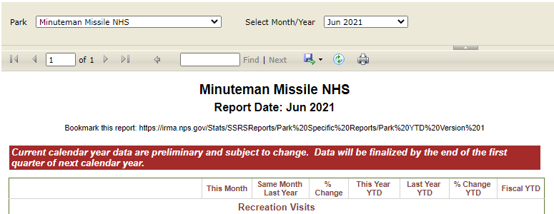

1. **Allow data users the capability to manually aggregate data for several parks at a time and see reports for a group of parks, and then save that query for themselves.**
   * Several users works with specific regions or park types (marine parks) and have to do a significant amount of manipulation to get data for a custom group of parks.
     + For example, there are over 80 marine parks that users have to check the boxes for each time they want to pull a report for all of them.
       - Allowing them to save that selection of 80 would save time.
2. **Create the option of selecting parks by region, similar to how a user can select parks by state.**

1. National Park Service. (2004). *Director’s Order #82: Public Use Data Collecting and Reporting Program*. https://www.nps.gov/policy/dorders/do-82draft.htm
2. Saugus Ironworks National Historic Park is one example of a park that has not updated count procedures since 1993 to date.
3. Clarin, B. M., Bitzilekis, E., Siemers, B. M., & Goerlitz, H. R. (2014). Personal messages reduce vandalism and theft of unattended scientific equipment. Methods in ecology and evolution, 5(2), 125–131. https://doi.org/10.1111/2041-210X.12132